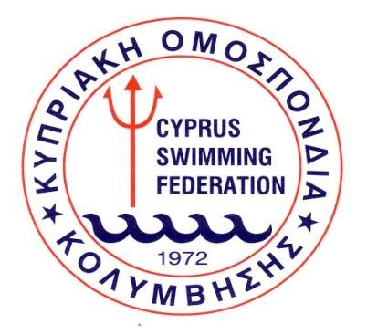

CYPRUS SWIMMING MARATHON
FOR MASTERS

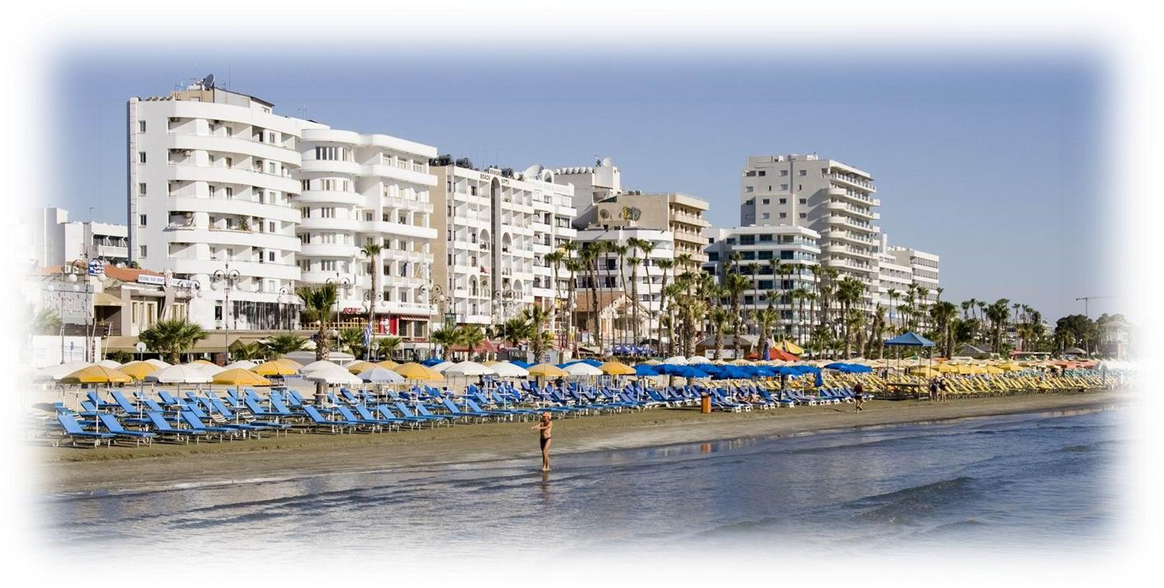

LARNACA - CYPRUS
8 October 2022

DATE
8th October 2022

ORGANISERS
The event is organised by the Cyprus Swimming Federation with the support of the Municipality of Larnaca.

Contact Person: | Mrs Maria Loizidou Kyriakou
Postal address: | P.O. Box 23931, 1687 Nicosia, Cyprus
Phone: | +357 22449840
Email: | koek@logos.cy.net
Website: | www.koek.org.cy

LOCATION
Open sea area in front of Phinikoudes Beach, City of Larnaca.

RULES
The event will be conducted in accordance to FINA Open Water Swimming Rules and Regulations.

DISTANCE
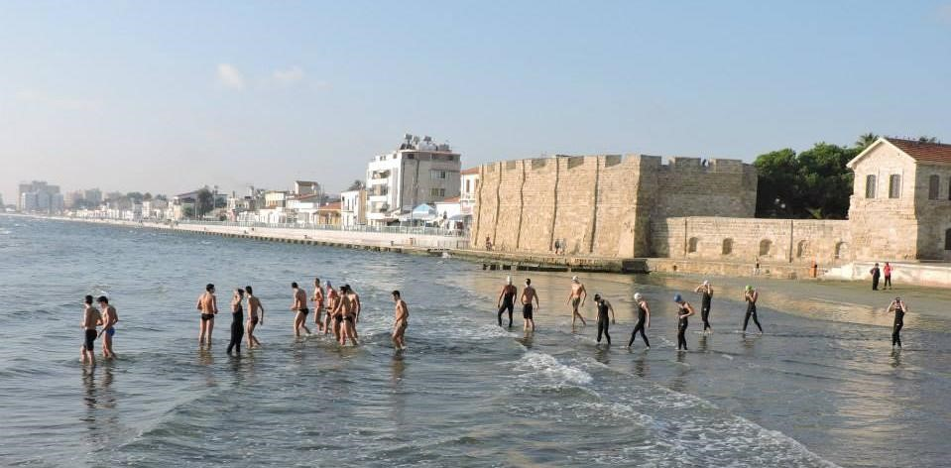
2.5km for women and men 25 years and older

CATEGORIES
Category A: 25-29
Category B: 30-34
Category C: 35-39
Category D: 40-44
Category E: 45-49
Category F: 50-54
Category G: 55-59
Category H: 60-64
Category I: 65-69
Category J: 70-74
Category K: 75-79 etc

HEALTH CERTIFICATE / DECLARATION FORM
All participants must be in good health and assume full responsibility for their participation by signing a declaration form.

PARTICIPATION FEE
Before the start of the race each competitor must present to the Secretariat a valid passport or identity card and pay a participation fee of €20.

PRIZES
Cup and medal for the 1st place athletes and medals for the 2nd and 3rd place athletes for each age category.

TIME LIMIT
The time limit of 15 minutes from the finish time of the first swimmer in each age category, will be applied.

COURSE
1250m long clearly marked as per the diagram below. Water temperature expected between 23°-26° C. The water depth will be between 2 and 4 meters.

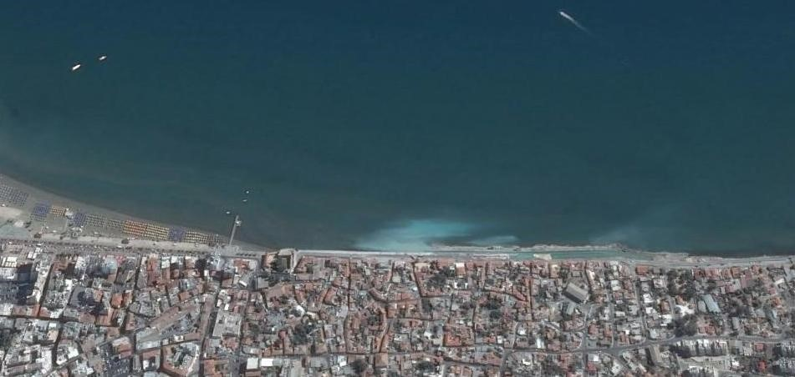
Finish

Start

50
m

5
75
m

ENTRIES
All entries must be submitted before Thursday 29th of September 2022.

SCHEDULE

08.00 Registration
09.00 Registration closing
09.10 Briefing of athletes
09.20 Swimmers’ presentation
09.30 Start for 2.5km men
09.35 Start for 2.5km women
12.00 Awards ceremony

CYPRUS SWIMMING MARATHON

Larnaca, 8 October 2022

ENTRY FORM 2.5km (FOR MASTERS)

Please return this form not later than the 29th of September 2022
by Email: koek@logos.cy.net

Name: ………………..…………………………………………………………….……………….…………… Nationality: ……………………………………………………………. Male: Female:
Date of birth: ………………….……………..…… ID or Passport No: …………………………….
E-mail ………………………………………….………..…..… Fax: ….…………………………….………
Phone: ………………………….…..………………..…..….. Mobile: …………….…...….……….…….

DECLARATION
I hereby declare that am aware of and appreciate the inherent risks involved in such competition and that I have recently been examined by a doctor. I am absolutely fit and healthy to participate in the above event.
The Cyprus Swimming Federation is not liable for any personal injury or any injury inflicted to other contestants from my mistake before, during or at the end of the events, or for any loss or damage to personal belongings.

Signature: ............................................................. Date: ……….......................

- Copy of the passport or I.D. card must be sent with this Form

- Before the start of the race each competitor must present to the Secretariat a valid passport or identity card and pay a participation fee of €20.

